Welcome to Word

  - 4 Tips for a simpler way to work.

Explore without leaving your doc

Smart Lookup brings research directly in to Word.
Try it:

- Right click the word office in the following phrase: office furniture
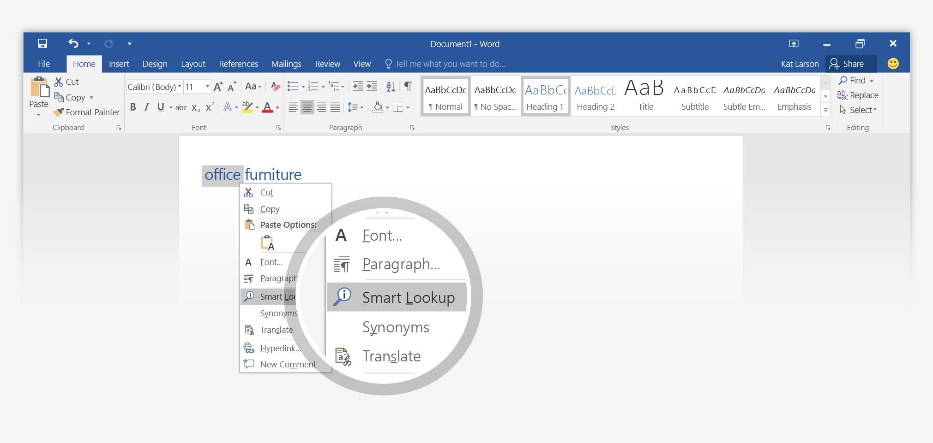
- Choose Smart Lookup.
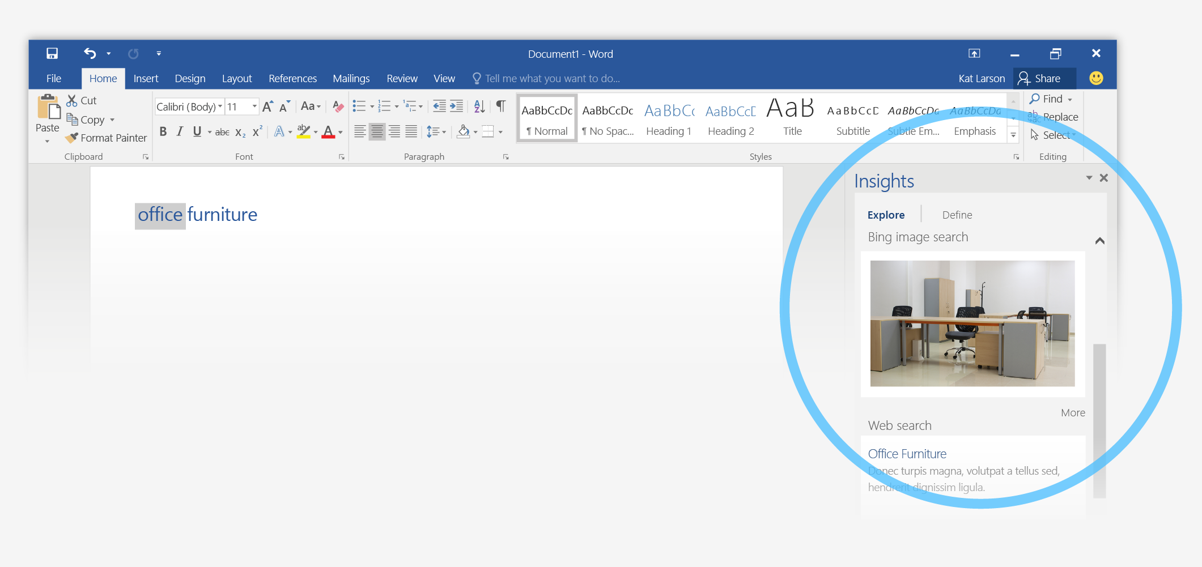
- Contextual results from online sources like Bing and Oxford Dictionaries are relevant for this use of the word office.
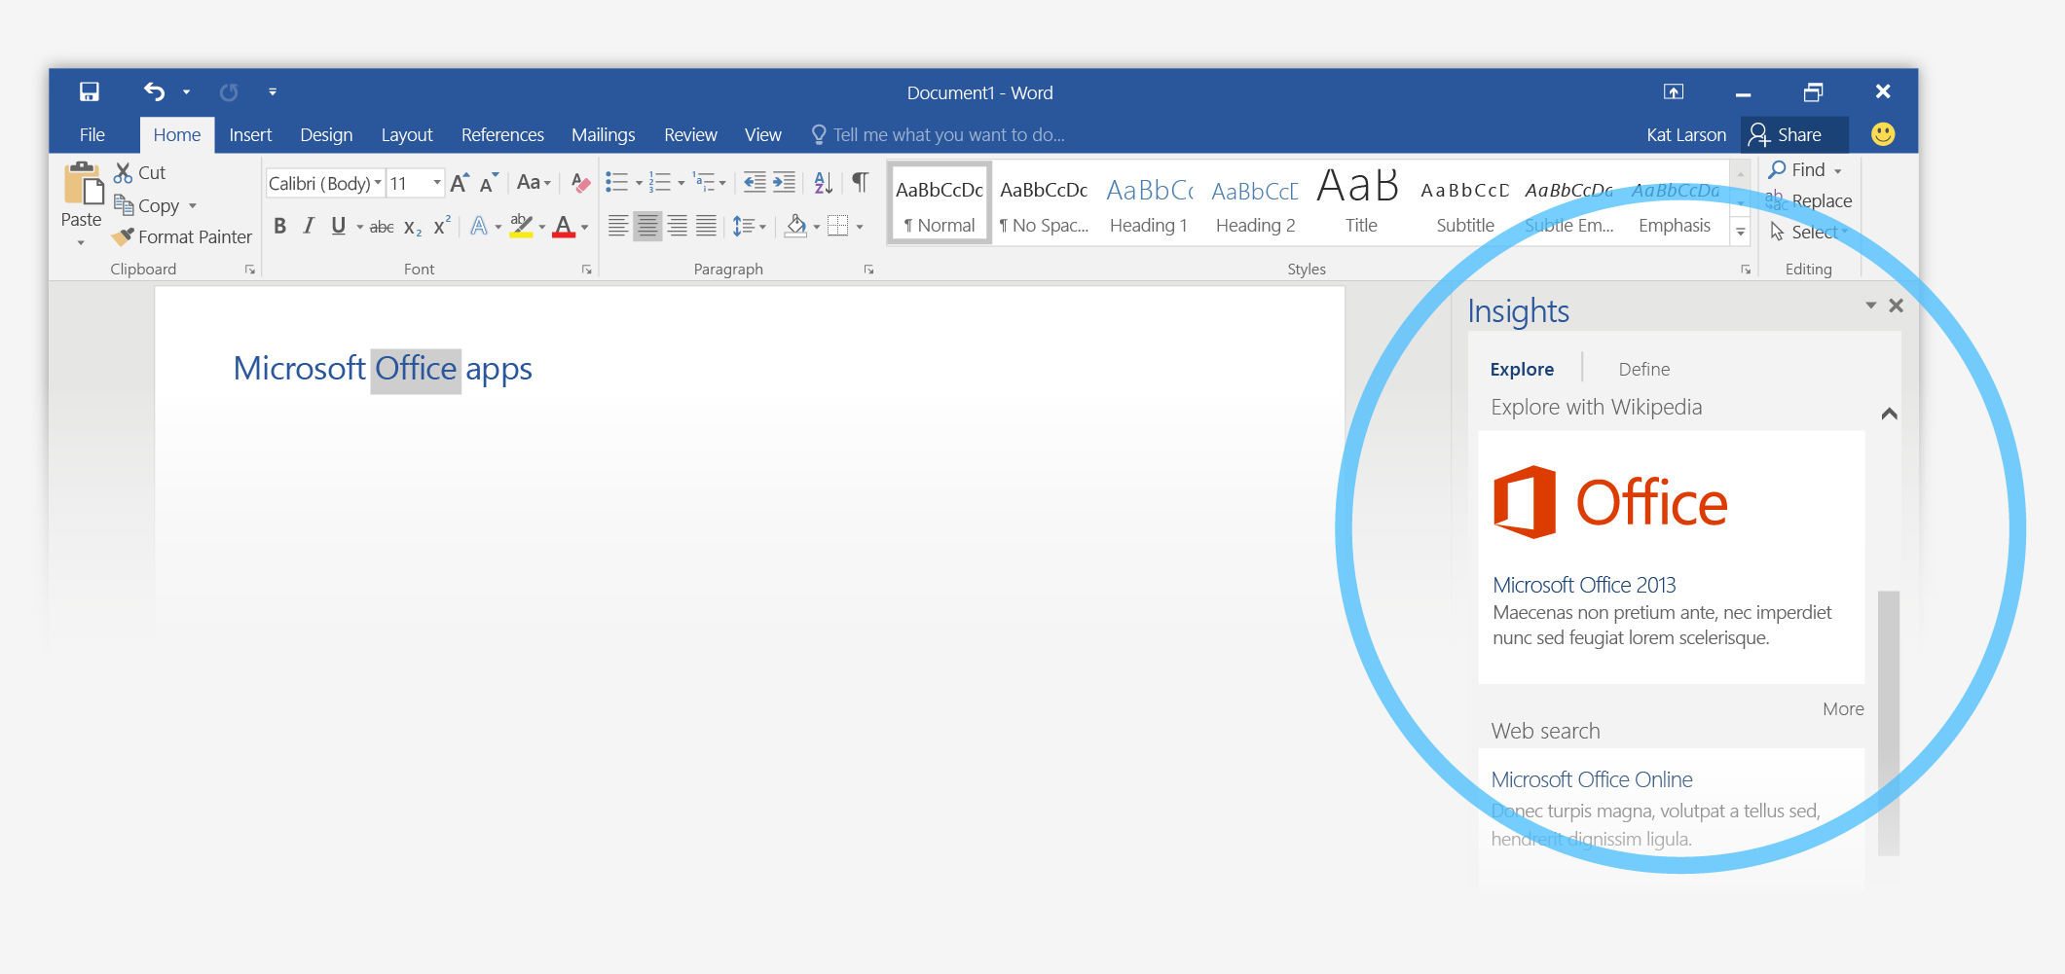
- Notice that you get different results when you change the context. Try Smart Lookup again by right-clicking office in this phrase: Microsoft Office apps

You’re an expert with Tell Me

The Tell Me box finds the right command when you need it, so you can save time and focus on your work.
Try it:
- Double click this word: Adventure

- Type reflection in the Tell Me box,
and point to Text Effects.
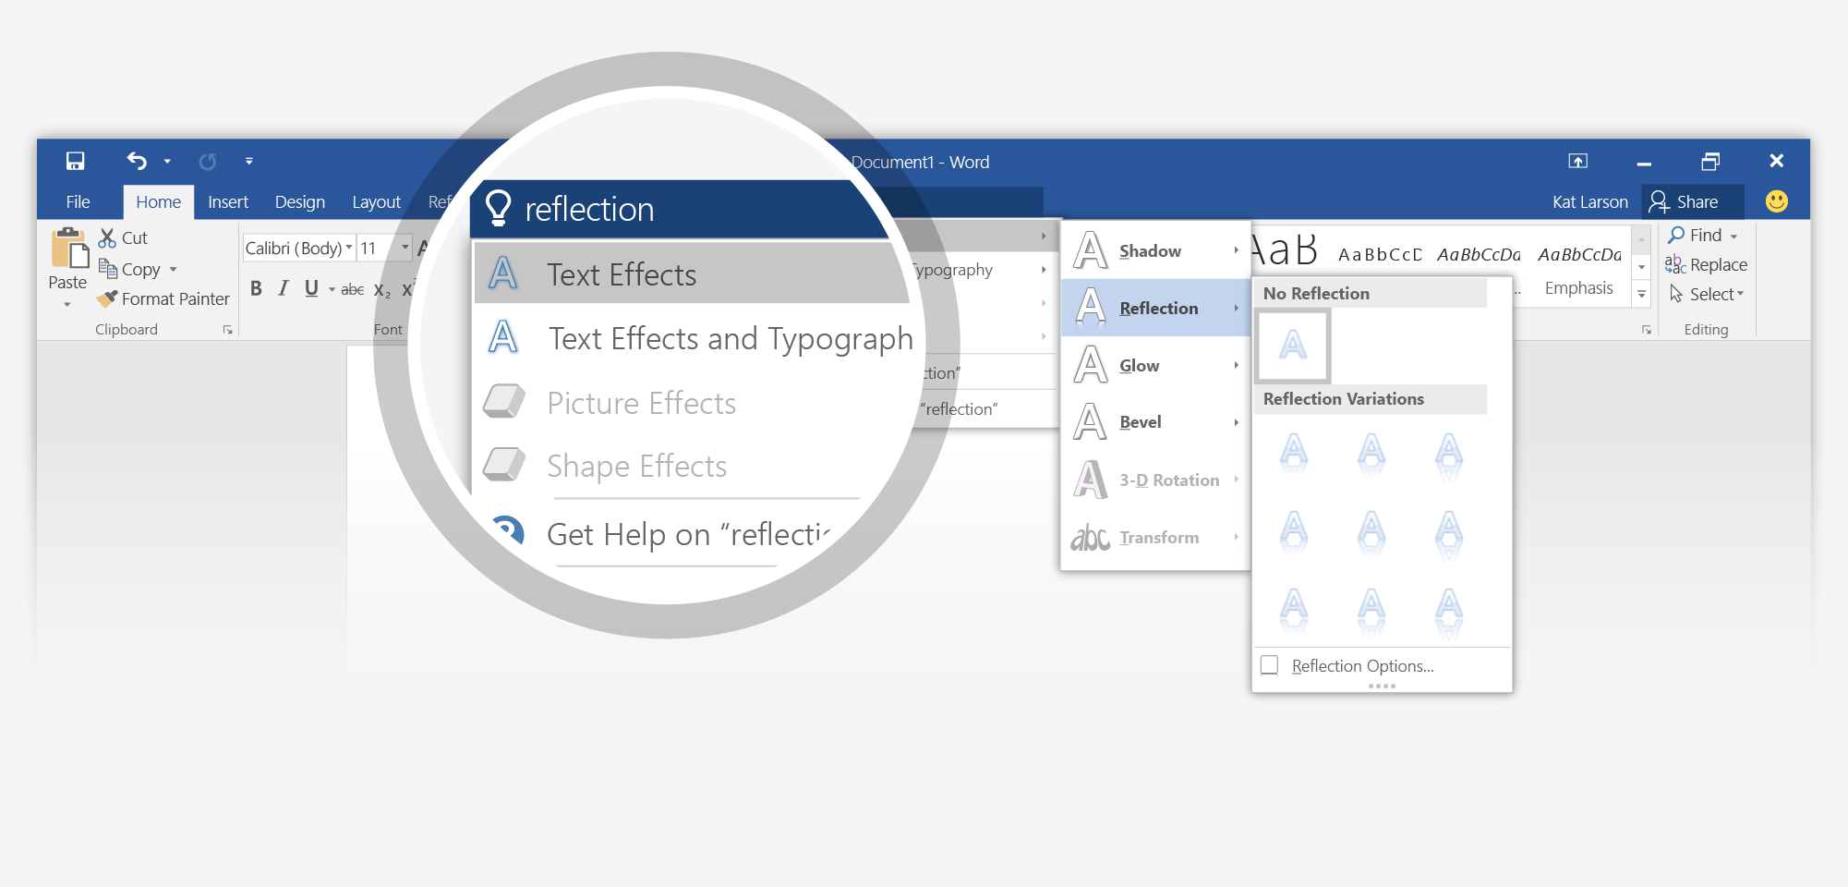
- Point to Reflection, and choose one of the Reflection Variations.

Look professional, your way

In this document, styles like Heading 1 and Title have been applied to text (Home tab, Styles gallery). That lets you quickly overhaul the look of the whole document.
Try it:
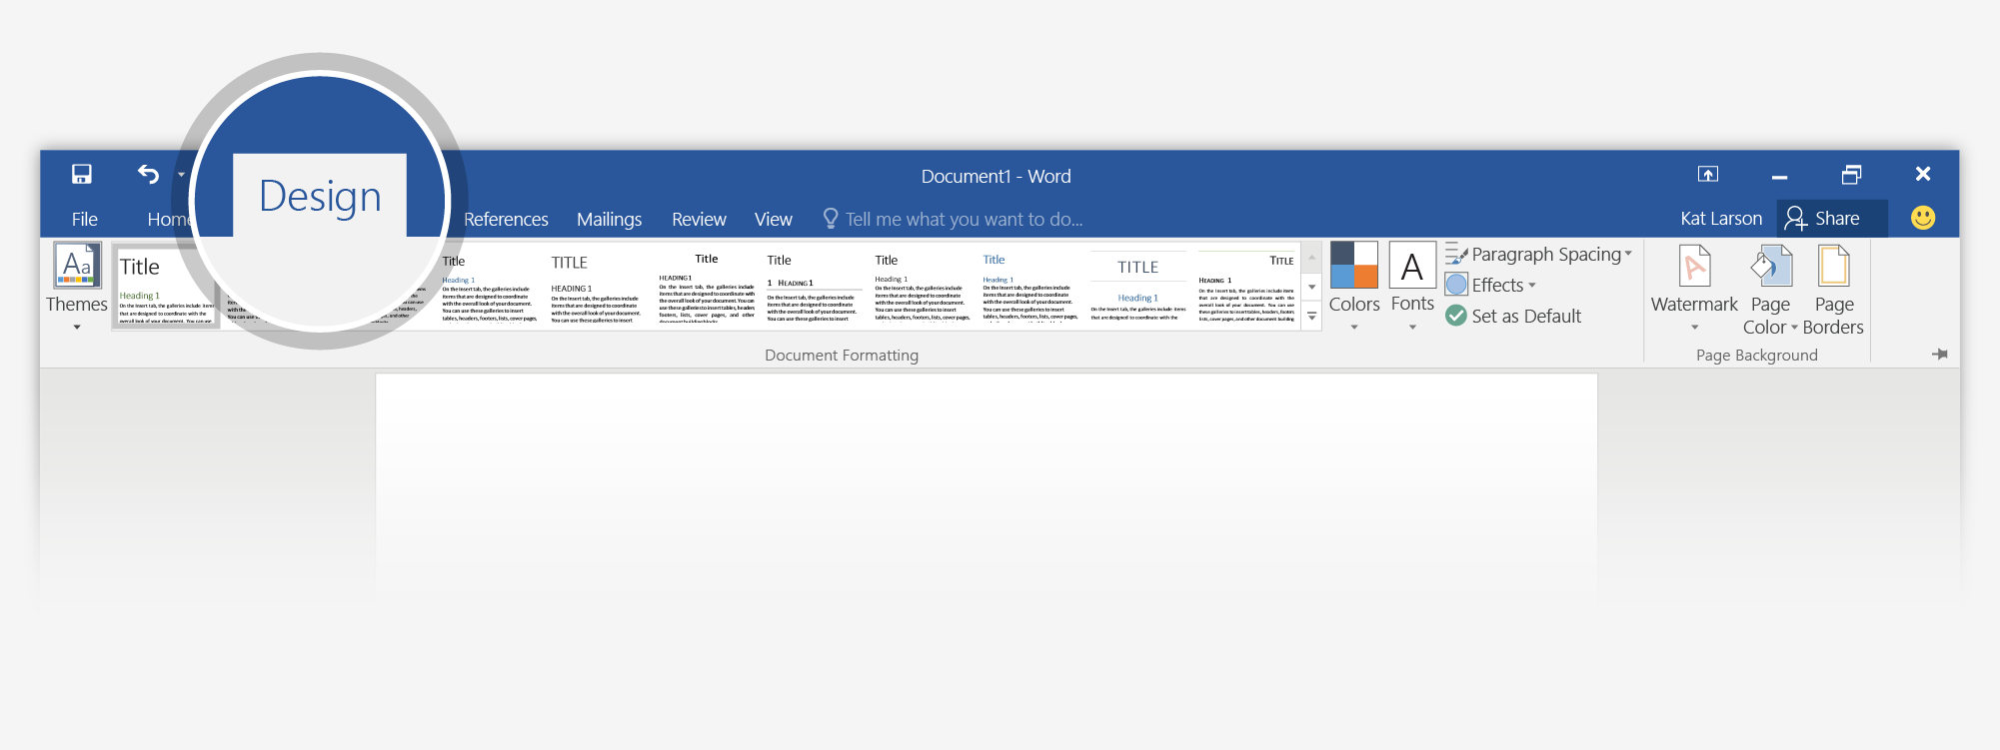
- On the Design tab, point to the different Style Sets and watch the formatting change automatically.
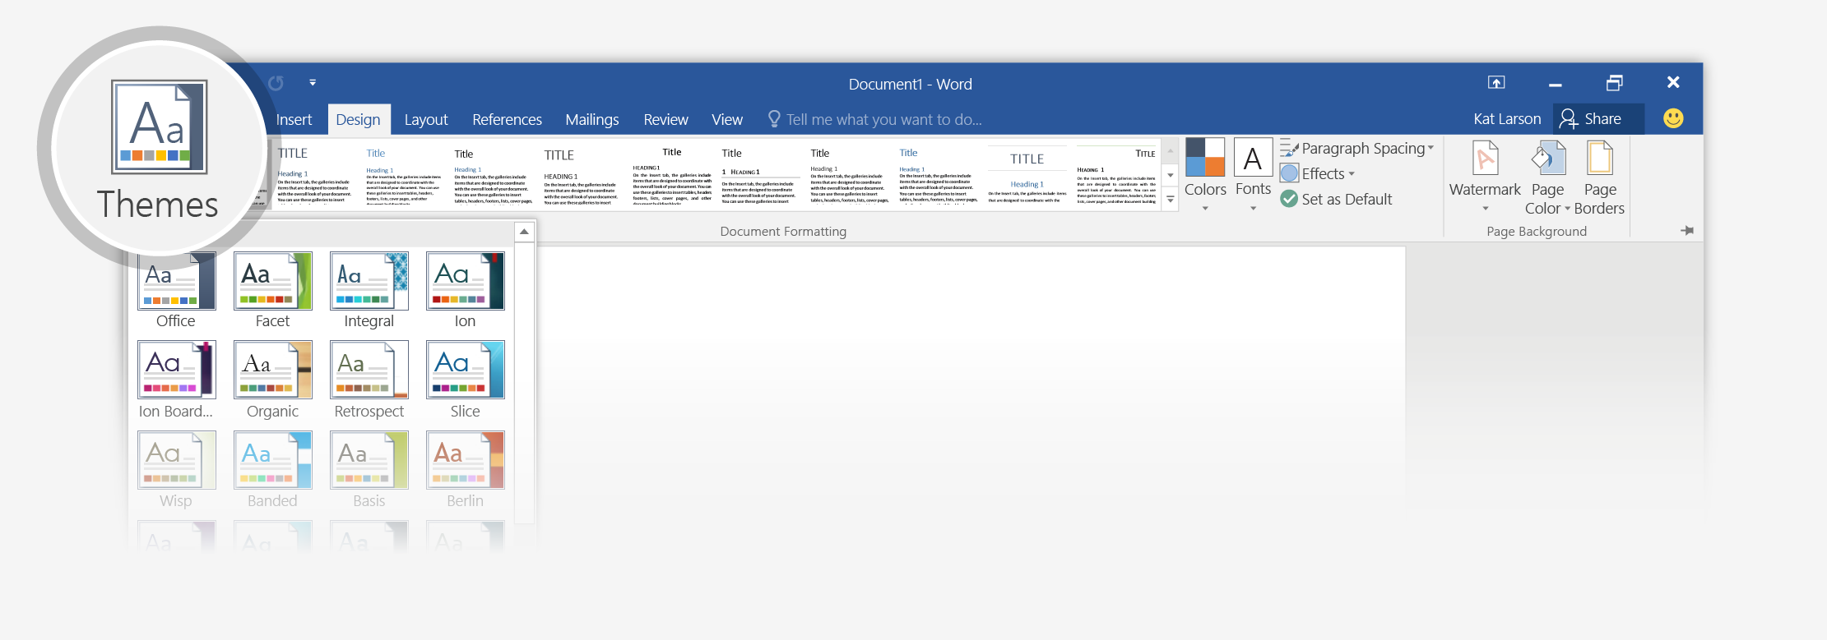
- Go to Themes and watch how colors and font change with the various choices.
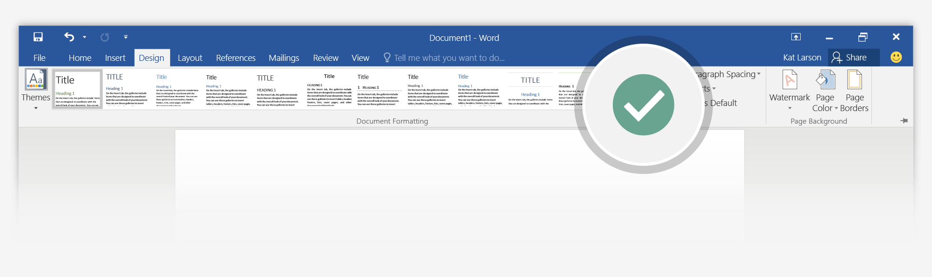
- When you get the design you want all your docs to start with, choose Set as Default.

Work together in real time

With your document stored in the cloud, you and your colleagues can open it at the same time and see each other making changes.
How it works:
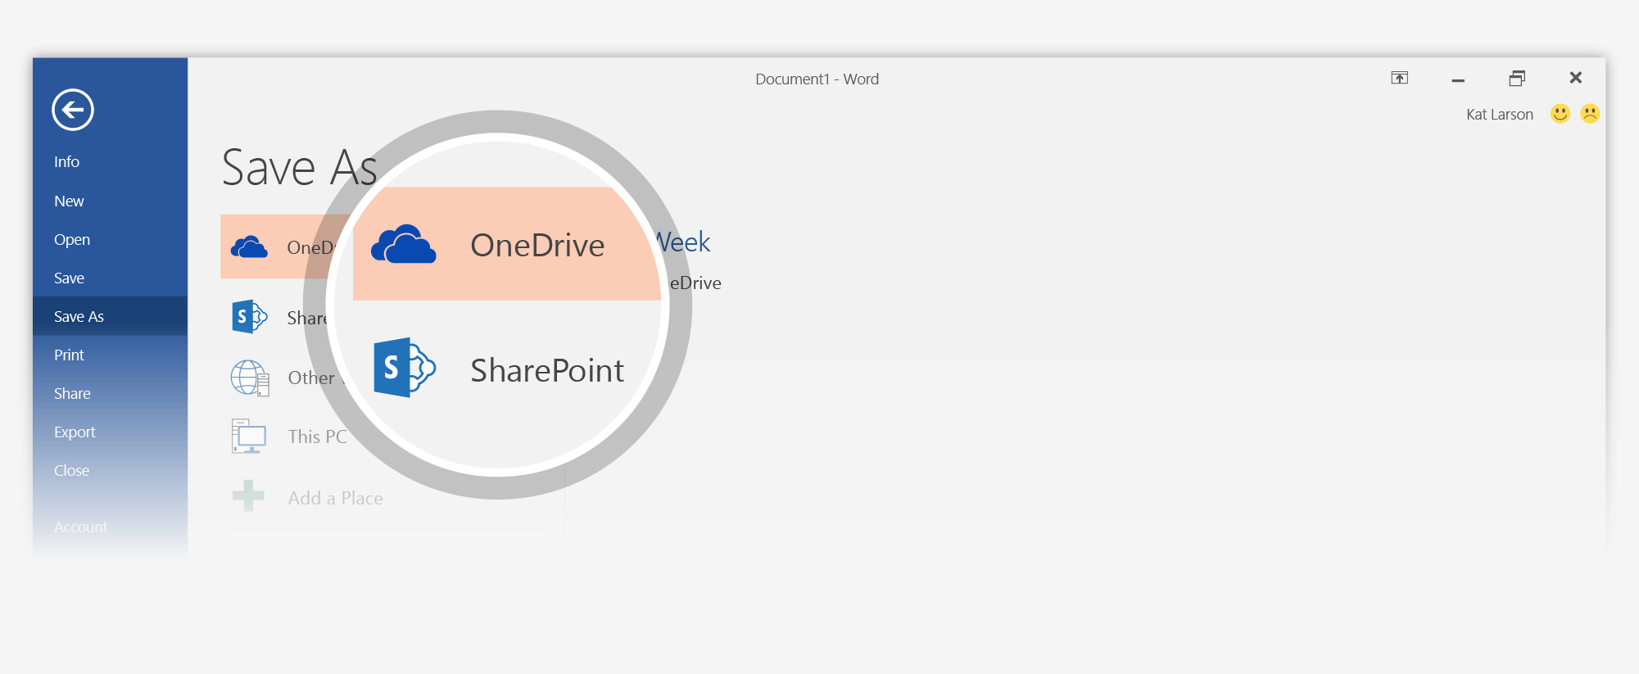
- Go to File > Save As, and choose a OneDrive or SharePoint location.
If you’ve never done this before, click Add a Place, and then add your OneDrive or SharePoint service by signing in.
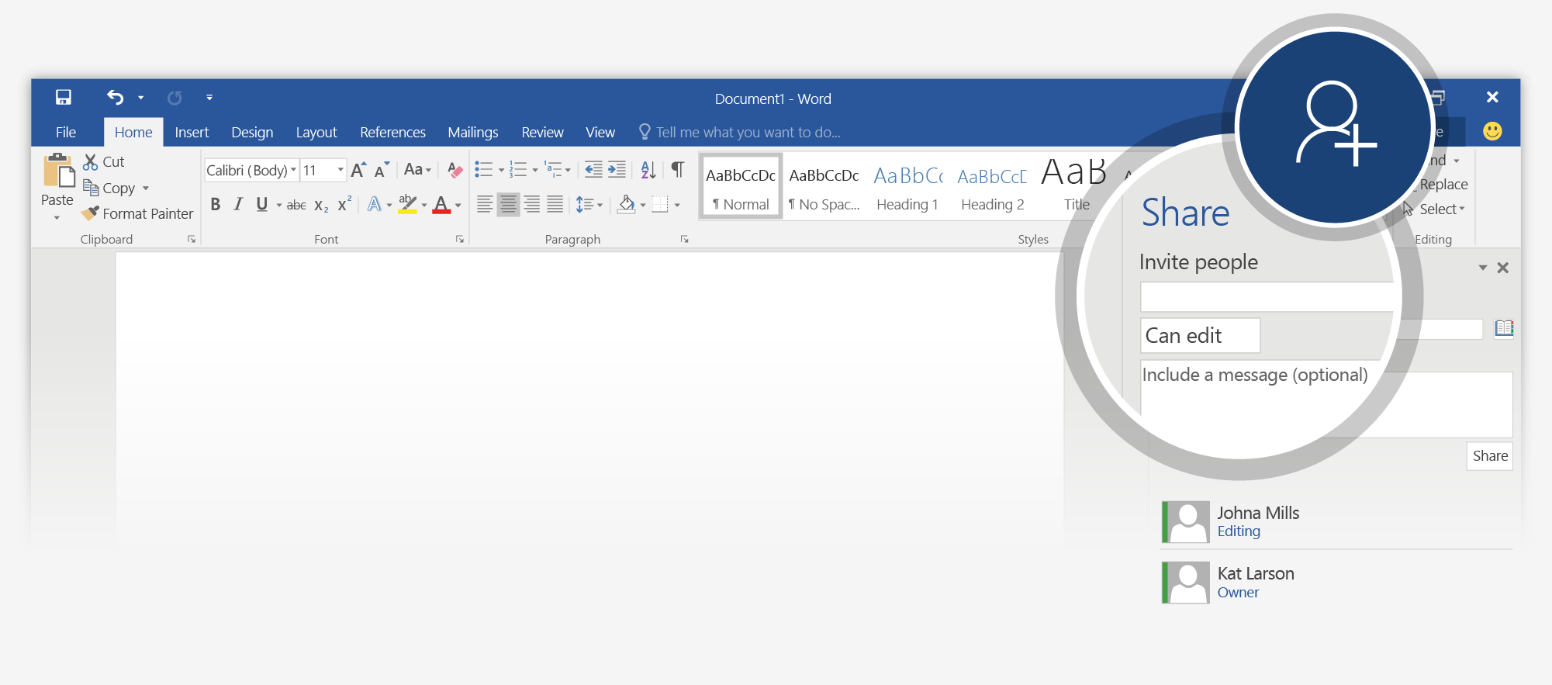
- Back in the document, click Share in the upper right, and invite people so they can edit with you. They’ll get email with a link to your doc.
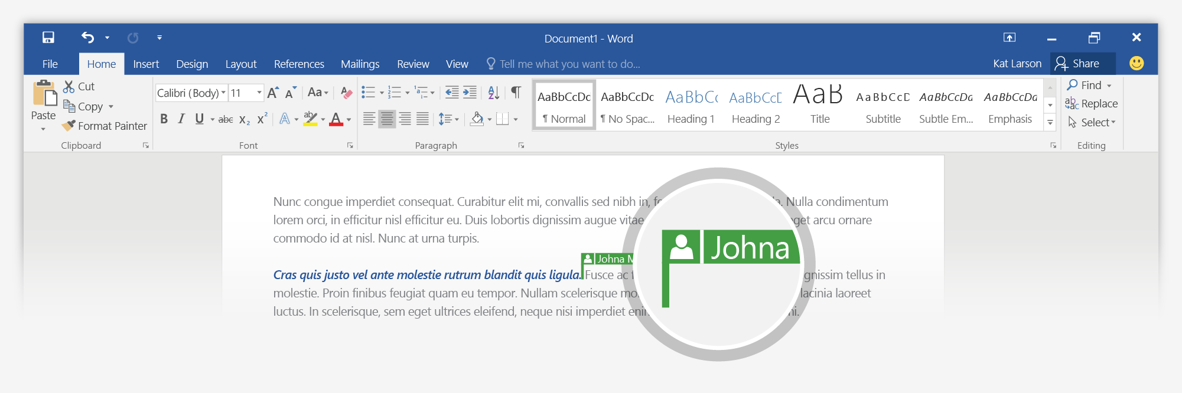
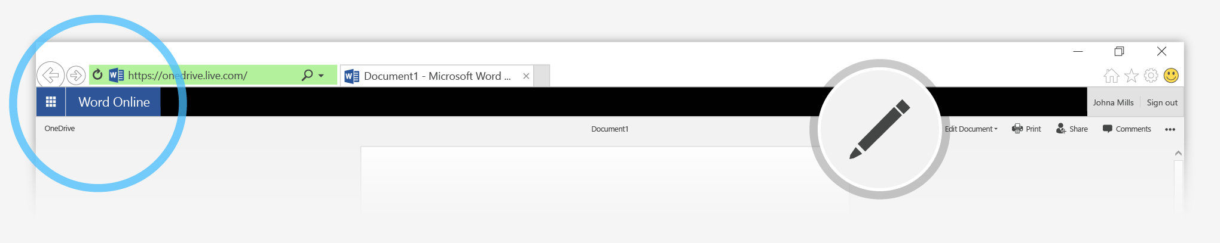
When they follow the link, your doc opens for them in their version of Word, or in their web browser (Word Online).
If they’re using Word Online or Word 2016 and have agreed to automatically share changes, you’ll see each other working in the same document.
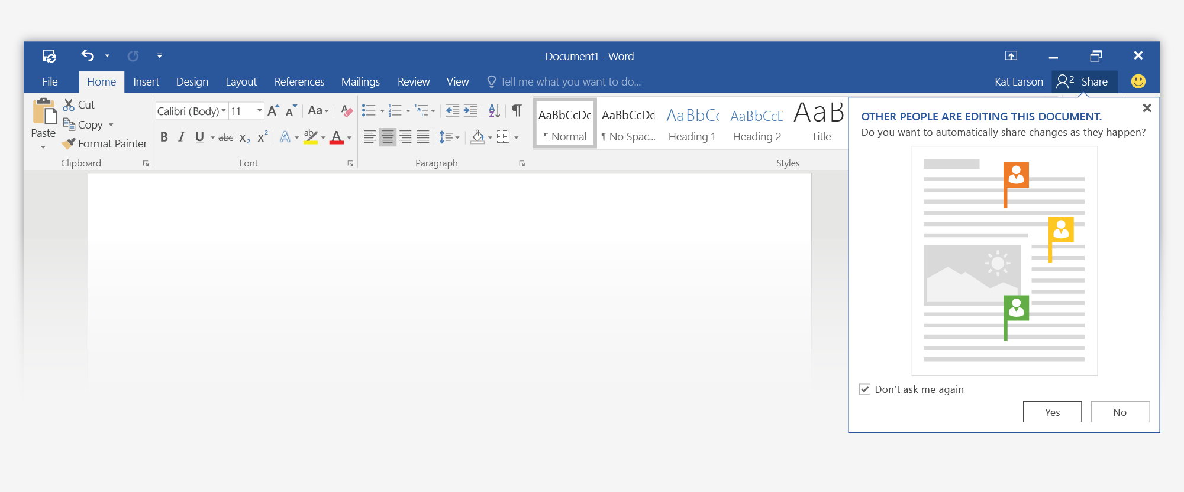
Note: The first time you do this in Word 2016, say Yes to automatic sharing.
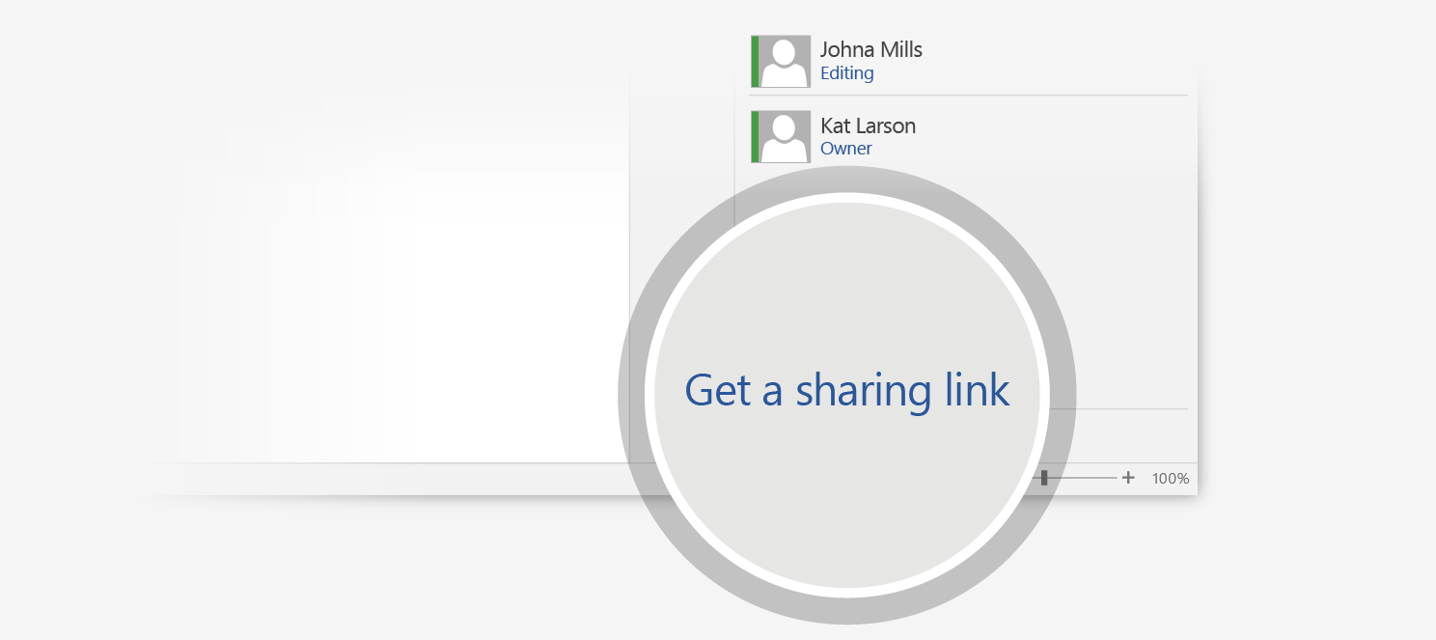
Tip: If you’d rather skip the email, Get a sharing link instead, and then create an edit link you can send.

More questions about Word?


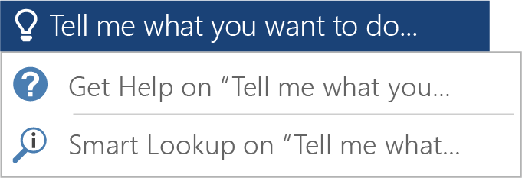
Click the Tell Me button and type what you want to know.

Visit the Word team blog.
Go to free Word training.
Find out more at the Word Getting Started Center

